TITLE: SUBTITLE

Purpose: [Text Body] (Required field)
Design/methodology/approach: [Text Body] (Required field)
Findings: [Text Body] (Required field)
Research limitations/implications: [Text Body]
Practical implications: [Text Body]
Social implications: [Text Body]
Originality/value: [Text Body] (Required field)

Keywords: [Text Body] (Required field)
1. Main headings (Level 1) (Verdana 11)
[Text Body] (Verdana 10)

  - Second-level headings (Verdana 11)
[Text Body]

Third-level headings (Verdana 11)
[Text Body]

Equations:
Intellectual Capital = Competence · Commitment | (1)

Table:
 | Information 1 | Information 2
Information A | Text | Text
Information B | Text | Text
Table 1. Information about
Figures:
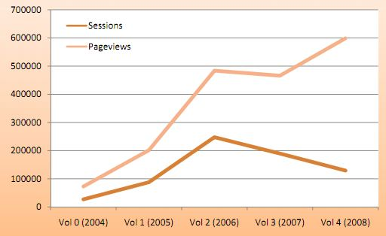
Figure 1. Intangible Capital: Sessions and page views (Simo & Sallan, 2009)

Declaration of Conflicting Interests
The author(s) declared no potential conflicts of interest with respect to the research, authorship, and/or publication of this article.
Note: if there is some conflicting interest, please detail it.

Funding
The author(s) received no financial support for the research, authorship, and/or publication of this article.
Note: if the author(s) received financial support, please detail it.

References
Please write cites in text using the last edition of APA style. Here, you can find the most important rules; however, you can find the complete rules in the American Psychological Association (http://www.apa.org/).
Examples:
Sallan, J. M., Enache, M., Albareda, M., Fernandez, V., & Simo, P. (2010). An overview of JIEM’s second year, and a prospect of its third. Journal of Industrial Engineering and Management, 3(1), 1-10.
doi:10.3926/jiem.2010.v3n1.p1-10
Lederman, R., Shanks, G., & Gibbs, M.R. (2003, June). Meeting privacy obligations: the implications for information systems development. Proceedings of the 11th European Conference on Information Systems. Paper presented at ECIS: Naples, Italy. Retrieved June 29th, 2009, from: http://is2.lse.ac.uk/asp/aspecis/20030081.pdf
Silverman, D. (2005). Doing qualitative research. London: Sage Publications.
Luthra, S., Manju, Kumar S., & Haleem A. (2010). Suggested Implementation of the Green Supply Chain Management in Automobile Industry of India: A Review. Proceedings of National Conference on ‘Advancements and Futuristic Trends of Mechanical and Industrial Engineering, GITM, Bilaspur (INDIA), 12-13 Nov., 2010.

How to reference in the text?

A work by one author: Name the author in the signal phrase or in the parentheses each time you cite the work.
e.g.: Research by Barney (1991) showed...
e.g.: (Barney, 1991)
A work by two authors: Name both authors in the signal phrase or in the parentheses each time you cite the work.
e.g.: Research by Wegener and Petty (1994) showed...
e.g.: (Wegener & Petty, 1994)
A work by three to five Authors: List all the authors in the signal phrase or in the parentheses first time you cite the source:
e.g.: Research by Kernis, Cornell, Sun, Berry and Harlow (1993) showed…
e.g.: (Kernis, Cornell, Sun, Berry & Harlow, 1993)
In subsequent citations, only use the first author's last name followed by "et al."
e.g.: Research by Kernis et al. (1993) showed …
e.g.: (Kernis et al., 1993)
Six or more authors: Use the first author's name followed by et al.
e.g.: Research by Harris et al. (2001) showed …
e.g.: (Harris et al., 2001)
Unknown Author: If the work does not have an author, cite the source by its title in the signal phrase or use the first word or two in the parentheses. Titles of books and reports are italicized or underlined; titles of articles and chapters are in quotation marks.
Two or more works in the same parentheses: When your parenthetical citation includes two or more works, order them the same way they appear in the reference list, separated by a semi-colon.
e.g.: (Berndt, 2002; Harlow, 1983)
Two or more works by the same author in the same year: If you have two sources by the same author in the same year, use lower-case letters (a, b, c) with the year to order the entries in the reference list. Use the lower-case letters with the year in the in-text citation.
e.g.: Research by Berndt (1981a) illustrated that...
Endnotes and Footnotes
Manuscripts sent to JIEM should avoid the use of endnotes and footnotes.
Horizontal pages
Manuscripts sent to JIEM should avoid the use of horizontal pages

