Logistics Network Configuration for Seasonal Perishable Food Supply Chains

Purpose: The location of actors and production, transformation, commercialization and distribution facilities generate the configuration of the perishable food supply chain (PFSC). The logistics network design (LND) lead to different supply, storage and distribution environments and result in flows, these logistics operations have an impact on the performance of the chain of fresh agricultural products. Specifically, in the PFSC with seasonality, a temporary imbalance between supply and demand is generated, which affects the balance in the flows and affects the losses, costs and response capacity. This research study that problem.
Design/methodology/approach: A multi-echelon, multi-objective and multi-product model is established that determines the configuration of the logistics network of the PFSC with seasonally and allows actors to approach efficiency frontiers, which contribute to their permanence in the markets. The model was applied to the case of the perishable fruit supply chain, in a developing country, Colombia. The population information was taken from government surveys and studies, which allowed parameterizing the model.
Findings: The application of model permitted to answer the next questions: How does improve the performance from PFSC through logistics network design? And, How the existence of smallholdings in food production and from retail merchants is preserved? In the perishable food supply chain.
Social implications: Where the perishable food supply chain actors are located in non-efficient borders and their sustainability may be affected by competition factors, the stakeholders should focus on increasing food availability and reducing losses to improve access and therefore food security.
Originality/value: A new model for the logistics network configurations of seasonal perishable fruit supply chain was development, the optimizing from five objectives with two sub-models is obtained, one for surplus and the other for de deficit moments. The model includes real conditions, such as, fruit loss due T0 and RH by different thermal floors and the means used for the transport of fruits in mountain areas at countries in route of development. The impact over the small producers, retailers and consumers in the times of scarcity or surplus was analyzed.

Keywords: Optimal Multi-objective Model; Seasonal Fruit perishable; Security Food; Food Supply Chain.
- Introduction
The food chain of agricultural products includes growers, processors, wholesalers, importers and exporters, retailers and specialty stores (Van der Vorst, J G; Da Silva, C. A, C A; Trieneken, n.d.), as well as input suppliers and logistics services. Agents are connected by the food flow resulting from commercial transactions (Argenti , Olivio Marocchino, 2007) The perishable food supply chain (PFSC) differs from others because of uncertainty in supply, variability related to climate; relatively low prices and margins (Lowe & Preckel, 2004), and especially the seasonality in the production of some foods (Orjuela-Castro & Adarme-Jaimes, 2018).
Consumers of fresh foods such as fruits and vegetables demand better properties and greater variety. The short shelf life of food makes management difficult, the perishable nature makes its logistics difficult (Aramyan et al., 2006). In the PFSC there is a continuous change in the quality of the product from the moment it leaves the cultivator until it reaches the consumer, which generates losses. It is estimated that one third of world food production is wasted or damaged (Gustavsson J, Cederberg C, Sonesson U, 2011), in developing countries post-harvest losses often exceed 50% (WFPC LLC, 2014).
The location of the actors and the production, transformation, commercialization and distribution facilities generate the SC configuration. Due to the importance of geographic dispersion, the intensity and frequency of the flows between these facilities, modeling techniques such as simulation or optimization have been applied to achieve better performance measures in the PFSC. The optimization allows establishing the best location of the facilities and the operation. The food supply chain (FCS) studies are recent, with few logistics articles on perishable foods (Orjuela Castro & Jaimes, 2017).
The duration and conditions of logistics operations have a significant impact on the performance of a logistics network for fresh agricultural products. Logistics network designs (LND) lead to different conditions of supply, storage and distribution (Orjuela-Castro & Adarme-Jaimes, 2018). When making decisions on LND, the consequences of delivery time and quality must be taken into account as food deterioration is not uniform and generates heterogeneity in its degradation (de Keizer et al., 2017). Logistic flows in the PFSC are influenced by the LND, which affects losses and food security.
Different studies on the PFSC propose improvements to farmer supply and urban demand. Researchers have studied how to make logistics of producers more efficient the with cluster formation (Bosona & Gebresenbet, 2011), better infrastructure in collection centers or processing plants, transportation, or the use of information and communications technologies (Johnson et al., 2015) and the formation of value chains in spatially close producers (Clark & Inwood, 2016). A tendency in European countries is to develop short chains with direct sales, quality processes and identification of origin, organic agriculture with traceability systems (Renting et al., 2003). Regarding demand, the authors study competitive vs. collaborative markets in FCS retailers, (Accorsi et al., 2018) improve logistics performance by forming demand clusters. Other studies evaluate the consumption habits between races and the practices and culture in food consumption (Shannon N. Zenk et al., 2012).
Food security (FS) includes sufficient and stable availability of food supplies, timely and permanent access to them in quantity, quality and safety (CISAN-ICBF, 2013; IICA-PRODAR, 2009). The balance between logistic flows could affect the FS, given its effect on availability and access (Orjuela Castro & Jaimes, 2017). (Hammond & Dubé, 2012) propose a socio-ecological approach that show tradeoffs between the FS and (Gerber, 2014) includes sustainability, due to food systems are vulnerable to climatic conditions (Manzini & Accorsi, 2013). Another factor that threatens the availability of food is the production of biofuels, reason why tradeoff studies between FS, sustainability and efficiency have taken greater interest (Orjuela Castro, Aranda Pinilla, et al., 2019). Food sustainability must guarantee a significant number of bidders and minimize oligopolies or monopolies (Farahani et al., 2014), the exclusion of farmers from the state should be avoided. On the other hand, the existence of a large number of retail merchants reduces food security risk (Accorsi et al., 2018).
The LND in the PFSC presents challenges, given the problems they face in the complex real systems (Novaes et al., 2015), the multiplicity of decisions, scales, levels, periods, objectives and the interested parties (Miranda-Ackerman et al., 2017). The models do not incorporate their inherent characteristics (Manzini & Accorsi, 2013), such as the incidence of the cold chain, shelf life, organoleptic attributes or freshness and innocuity (Soto Silva et al., 2017), There is a need to include temperature behavior in the shelf life of the food, as well as in transport and inventory (Hsiao et al., 2018; Orjuela Castro, Orejuela, et al., 2019). formulate a last-mile distribution plan problem with concern for the quality of fruits and vegetables in cold chains, a vehicle routing problem with time windows (VRPTW), the properties of multiple perishable foods, continuing decline in quality, various requirements for quality levels and optimal temperature settings during vehicle transportation are considered. Research papers are found in developed countries, future research in developing countries should focus on reducing losses and increasing food availability (Lemma et al., 2014). It is found that the models leave out key stakeholders such as processors, supermarkets and retailers (Utomo et al., 2018). In the PFSC there is an imbalance between supply and demand, with periods of high and low supply being generated while demand does not respond in the same way, which affects the balance in the flows (Orjuela Castro, Diaz G, et al., 2017).
Some papers for the food SCND are presented below. (Gong et al., 2007) Resolved inventory and location problem as developing a distribution network design. To minimize both the total inventory transportation cost of fresh food and wastes in the supply chain. (Tsao, 2013) presented a fresh produce supply network model is designed to determine the optimal service for the replenishment cycle time of agricultural produce marketing corporations and the freshness-keeping effort, while maximizing the total profit, the objective is to address the integrated facility location, inventory allocation. (Boudahri et al., 2013) Worked in the redesign of a real agri-food supply chain for poultry products and optimize the distribution planning. To this aim, a clustering-based location-routing model is applied in a sequential manner. (Govindan et al., 2014). Propose a multi-objective optimization model in a perishable food SC network, it introduce a two-echelon location-routing problem with time-windows, integrating economic and environment objective. (de Keizer et al., 2017) Showed how product quality decay as well as its heterogeneity can be integrated in a network design model from the horticultural sector, it is shown that heterogeneous product quality decay should be taken. (Musavi & Bozorgi-Amiri, 2017) Presents a sustainable hub location-vehicle scheduling multi-objective model, the model considers perishability of products for distribution in a food supply chain and total CO2 emission of hub network, simultaneously.(Yakavenka et al., 2019) develop and employ a multi-objective (namely cost, social-time and emission minimization) decision-making model for the network design of sustainable supply chains of perishable food products, the suggested model leads to a whole set of possible solutions incorporating trade-offs between three aspects of sustainability. Some researchers raise the need to use cold chain for food preservation.
Cold chain as a temperature-controlled supply chain has emerged to ensure the quality food, (Sun et al., 2018) proposed the methods to optimize the cold chain logistics distribution, adopted location set covering problem (LSCP) to model the location problem of cold chain logistics distribution center for a Factory. However, implementing cold chains for perishable foods in developing countries has difficulties as shown on (Gligor et al., 2018). While the (Shashi et al., 2018) study showed the importance of the cold chain in perishable foods, fresh foods are not transported cold on developing countries (Orjuela-Castro & Adarme-Jaimes, 2018), due to the difficulty of implementing cold chain in developing countries (Gligor et al., 2018).
Studies show the concern of producers by finding themselves in borders far from efficiency (Orjuela-Castro et al., 2018), and the interest of retailers to improve their performance responding to the different cultures of consumers, despite availability and access may be affected by competition factors, the questions arises: How is the existence of small farms in upstream food production in the FCS (Clark & Inwood, 2016) and downstream retailers preserved? Which would distribute the power of the market (Accorsi et al., 2018)?, How should a logistics network in the PFSC be configured and reconfigured in an environment of seasonality in which there are periods of over-supply and others of deficit?, What performance measures should be considered in each period that permit sustainability and food security?.
- Methodological Design

  - Model for the PFSC logistics network design
A multi-echelon, multi-objective, multi-product model is established that allows to determine the configuration of the seasonal PFSC Logistics Network and to approach the efficiency frontiers for performance measures, response capacity, quality and efficiency, which contributes to the permanence of the PFSC actors in the markets.
Location for facilities in the PFSC
The Multi-objective mathematical model proposed for SC perishable fruits (SCPF) was based on the model proposed by (Orjuela-Castro et al., 2017), which include different thermal floors and their impact on the perishability of different types of fruit. Perishability is calculated on the basis of three aspects: i) the loss of fruit due to the manipulation in the storage nodes, ii) due to climatic iii) and RH, changes derived from different thermal floors. In this investigation the excess inventory in the different nodes is considered, which forces to dispatch all the production of the farms or to incur a penalty for it. The model establishes the location of the collection centers and distribution (wholesalers), considers as offering nodes each municipality of producers and as plaintiffs nodes of transformation, market places, hypermarkets and shopkeepers, Figure 1.
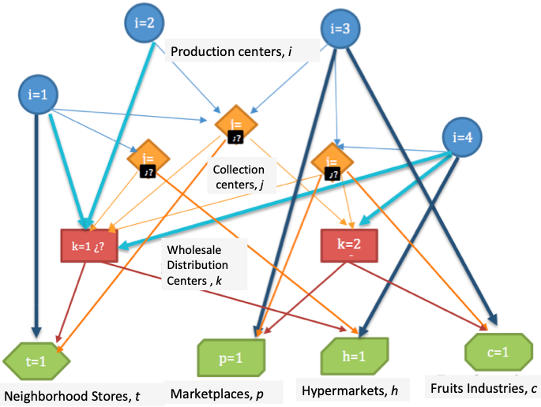
Figure 1. Graph Location Model
The general model optimizes based on five objectives. The formulation includes the definition of the sets, parameters, decision variables, the objective functions, the constraints (flow balance, capacity and demand) and the types of variables (see the appendix). The fundamental components of the formulation of the two sub-models, the oversupply and the deficit, are presented below.
General Objective Function.
The five objective functions minimize the costs of transport, service time and the loss of perishable food due to change of temperature (T°) and relative humidity (RH) and storage in warehouses, the other two objectives maximize the number of clients served and number of suppliers. The decisions are about opening of collection and wholesale centers, transport and the presence of excesses or shortages of different warehouses, the flows also are determined.
Variables and Constraints.
The variables are the opening of collection X_{j} or distribution centers Y_{k}, as well as the allocation of flow WN_{fod} and excess SFI. The constraints are those of flow balance for supply, demand and distribution in all echelons, those of capacity control for collection and distribution centers.
The set of constraints guarantees the flow balance for each agricultural zone i, for each perishable food f available, requires that the offer that each production zone i has for each available f food be sent to all destination nodes d, or stay in the production area (ZP). The flow balance is also guaranteed in each wholesale collection unit (CC) or wholesale (WD) k, for each food f that it can receive, for this, it is required that the amount of each perishable food (AP) that arrives from all areas of production (ZP) and of all the CCs, is equal to the amount that leaves from that type of AP towards all possible destinations of the CC/WD plus the excess of AP remaining in the CA/WD, taking into account the losses. The balance considers losses due to changes in T° and RH between the flows of the ZP-CC, ZP-WD and CC-WD due to storage.
The capacity constraints guarantee the flow relationship, between what leaves from the CC/WD and the decision to open the CC j or WD k. It means that if it is not open, no flow is sent from it, if the CC/WD is opened, it forces the flows to be greater than the minimum required opening capacity, and less than the maximum capacity of the CC or WD.
For each of the final customers (FC): Stores (t), Squares (p), Hypermarkets (h) and Transformers or industries (c), proportions of total demand are presented, which generates orders from suppliers: ZP, CC and /or WD. In this sense, there are constraints that guarantee that the demand is met. This requires that everything sent from ZP, CC and /or WD to each final customer (FC) is equal to what is demanded plus excess AP in the FC. Likewise, the balance considers the losses due to changes in T° and RH in the flows between nodes and storage.
Seasonality implications and sub-models.
For the evaluation of the performance of the SC, a series of metrics have been proposed, which can be classified into indicators of efficiency, response capacity and flexibility (Bigliardi & Bottani, 2010), in the FPSA there is a need to include quality , shelf life, product safety (Aramyan et al., 2006), access, availability, logistics performance and losses (Orjuela-Castro & Adarme-Jaimes, 2018). In accordance with the literature review and the PFrSC behavior at the region of the study, five performance metrics were selected. Therefore, there would be five objectives, which exceeds the recommended number in multi-objective optimization and an amount that cannot be represented in a three-dimensional scheme (Govindan et al., 2014). The PFSCs that present seasonality in the supply generate a relationship between supply-demand with periods of surplus or deficit. With the purpose of modeling that imbalance between supply-demand due to the seasonality in PFSC, the problem has been divided into two sub-models, one for the moment of over-supply and the other for periods of shortage, Figure 2. For the first case of oversupply, three objective functions are proposed: the reduction of losses, the variable cost of transportation and maximizing the number of suppliers involved. On the other hand, the scenario with scarcity requires including two objectives: to maximize the number of clients served and to minimize the attention time (Lead-time). Below are the two sub-models.
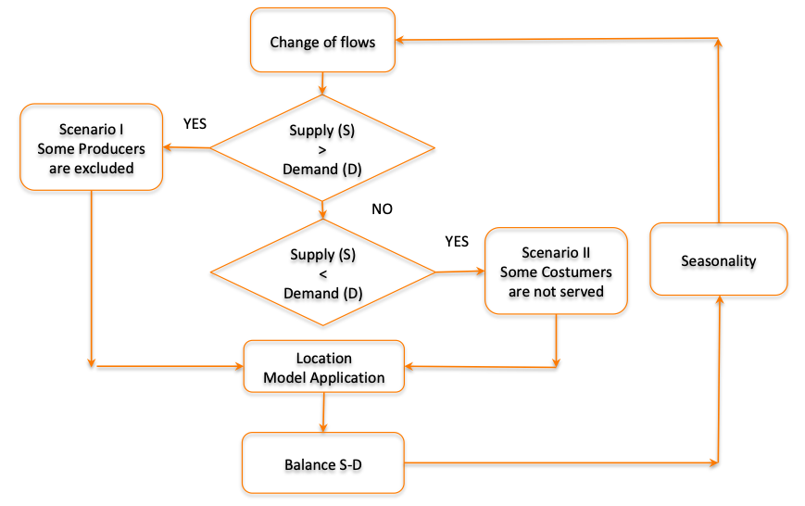
Figure 2. Decisions for the Configuration of the PFSC
  - Surplus model
For this model, the following objective functions are established.
Objective function
Minimize Z = F(OBJ1,OB2,-OBJ3) | (1)

Minimization of losses.
$$OBJ1=MINZ1=\sum_{o∈T}{\sum_{d∈DT}{\sum_{f∈\left(FOT\left\{o\right\}∩FDT\left\{d\right\}\right)}{{WN}_{fod}∗\left(Tn_{od}+HN_{od}\right)}}}$$ | (2)

This function seeks to reduce losses that depend on intermediate nodes, logistics and transport processes, preserve organoleptic and biophysical characteristics and generate availability and consumer satisfaction when the demand is met. In the consolidation centers the characteristics of packaging and conservation are improved by reducing losses, therefore the passage through these Hubs is favored. If the offer is less than the demand, there are only losses in the warehouses of final consumers.
Minimization of transport cost.
$$OBJ2=MINZ2=\sum_{o∈OT}{\sum_{d∈DT}{\sum_{f∈\left(FOT\left\{o\right\}∩FDT\left\{d\right\}\right)}{{CT}_{od}∗DIN_{od}∗{WN}_{fod}}}}$$ | (2)

The cost of transport grows by adding intermediate nodes since the distances traveled increase, therefore the decrease of them is sought. In developing countries, small vehicles are used in the first and last mile, which makes it difficult to find benefits by transport scale. The only cases in which these economies of scale occur are between collections centers (CCs) and warehouse distributions (WDs). This performance measure punishes the opening of the CCs or WDs, favors direct travel, and presents a positive relationship with the time of transport, dispatch, supply and the level and cost of inventory.
Maximize number of suppliers.
$$OBJ3=MAXZ3=\sum_{i∈I}{{BPI}_{i}}$$ | (3)

With the purpose of contributing to the permanence of smalls producers in the market, in times of oversupply, a model without this objective function excludes suppliers that, for reasons of distance, generate high transport costs, while by including it actively all suppliers with a minimum load, could to be generate excesses in the nodes or specialize the type of fruit to be sent from the supplier.
A new variable (BPI) appears that considers whether the farmer is included i, this implies the appearance of new constraints: redundant so that a producer that is not activated is zero, of opening and minimum flow from the supplier.
  - Deficit Model
Applies for moments of scarcity.
Objective functions.
Minimize Z= F (OBJ1, OB2, -OBJ3) | (4)

The first objective loss function does not change from the previous sub-model.
Minimization of the estimated average service time.
For each of the final customers d2∈ DF, the time is given by the weighted average of the service time each of the three echelons has: producers, CC and WD.
$$OBJ4=MINZ4=\frac{\sum_{d2∈DF}{{LTD2E}_{d2}}∗{DNT}_{d2}}{\sum_{d2∈DF}{{DNT}_{d2}}}$$ | (5)

Maximize the number of clients served in the process.
In times of deficit, a model without this objective function excludes retail customers; with it activates retail customers with minimal supply.
$$OBJ5=MAXZ5=\sum_{d2∈DF}{{BPD2}_{d2}}$$ | (6)

For the particular formulation of the supply deficit model, it was necessary to add the minimum demand parameter, the binary variable of appearance of a customer (retained retailer) and the redundant constraints, of control with minimum flow and the relations of flow and opening, of demand minimum and maximum for each echelon.
- Case studies. The SCPF Cundinamarca-Bogotá, Colombia.
Colombia has 32 departments, Cundinamarca is the third most populous with 2,800,000 inhabitants without Bogota, capital of Colombia. Cundinamarca has 22,623 km², located in the eastern mountain range, with a diversity of thermal floors and producer of a variety of foods. It supplies more than 60% of the food consumed by Bogotá, the most populous city with 7,674,366 inhabitants by 2018 and with 1,775 km2. Colombia.
In this context, the two sub-models were applied to five SC of perishable fruits (SCPFr), three fruits of warm climate and two of cold climate, this given the consumption in Bogotá and the production of Cundinamarca. Based on the application of the characterization methodology (Orjuela Castro, Díaz Ríos, et al., 2017), the behavior of the SCPFr was established. While a general model is obtained for the perishable fruit supply chain (PFrSC). The research proposal evaluates the PFSC for five fruits, which meant that the units of analysis were the actors of the SC of selected fruits, two fruits of cold climate blackberry and strawberries and three of warm climate Mango, Tangerine and Orange in the region of Cundinamarca-Bogotá, Colombia.

  - Survey of information
The gathering of information allowed establishing the behavior of market competition and flows. The field data was obtained from surveys applied to the SCPFr actors in two periods, between 2014-2015 (GICAL group and Universidad Distrital) and between 2016-2017 (SEPRO group and National University). The primary information was supplemented with secondary information through documents of the Ministry of Agriculture 2006-2016 for the Agronet offer, for demand, studies from the Secretariat of Development of Bogotá 2006-2009 and the ENSIN survey 2005, 2010 and 2015. The above was complemented with data from FAO, WTO and TRADE-MAP. Six possible municipalities of Cundinamarca were taken for location of CCs, as WDs four possible locations in the extremes of Bogotá. On the other hand, 24 municipalities and as customers 5 market places, 5 large hypermarkets, 2 agribusinesses, 12 locations (where retailers are located).
Through non-probabilistic sampling, 109 surveys were applied to producers, 65 to transporters, 3 to agribusiness, 3 to large hypermarkets, 350 to shopkeepers in the neighborhood, 154 to merchants in market places and 79 to wholesalers in Corabastos, the largest supply square of Bogotá. The number of questions included was 132 to the different actors, establishing the behavior of 251 parameters. Which allowed establishing the demand of the industry, wholesalers, shopkeepers and market places in Bogotá, the offer from Cundinamarca to Bogotá, the parameters of transport and storage times and costs, fruit losses in the PFrSC, rates of production, per capita consumption and flows between the different links.
- Results
The two Multi-objective sub-models for the different seasonal, allowed establishing new configurations of the SCPF, according to the five performance measures. The purpose was to determine how many facilities and where the CCs (Cundinamarca) and WDs (Bogotá) should be located. Then determine the allocation and flows between the nodes, the SCPFr is reconfigured and evaluates how it affects the actors by placing them in performance measures closer to efficient borders.

  - Sub-Models
For the surplus sub model, three objectives were evaluated, 250,000 runs were carried out in AMPL to obtain the borders. In the sub-model with supply deficit contemplated three objectives, 260,020 runs were made. The e-constraints method was applied, the total variables were 2401, 33 binaries and 2368 linear, 422 equality constraints and 1514 with inequality. The solutions were obtained through Gurobi 7.5.0.
Figure 3 shows the results of the objective functions, plotted in Matlab. In (a), the Pareto border obtained by applying the non-dominance technique, proposed by Wilfredo Federico Pareto (1848-1923), is presented for the three objective functions of the surplus sub-model, in (b) the three objective functions of the sub- deficit model, applying e-constraints. In the figure, it can be seen that the application of the designed submodels, allowed determining the borders of Pareto, orange, which demonstrates the robustness of the model and the goodness of the applied technique of solution.
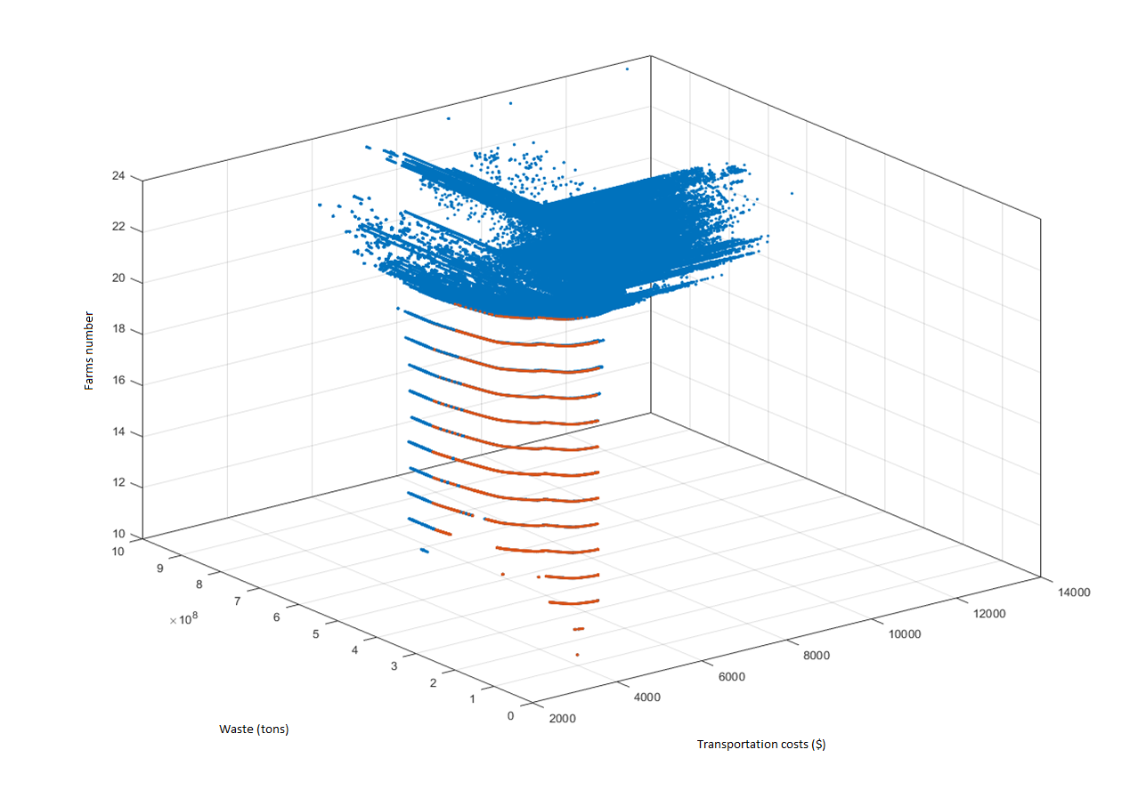
- Efficient Pareto Borders (5440) for the surplus sub-model
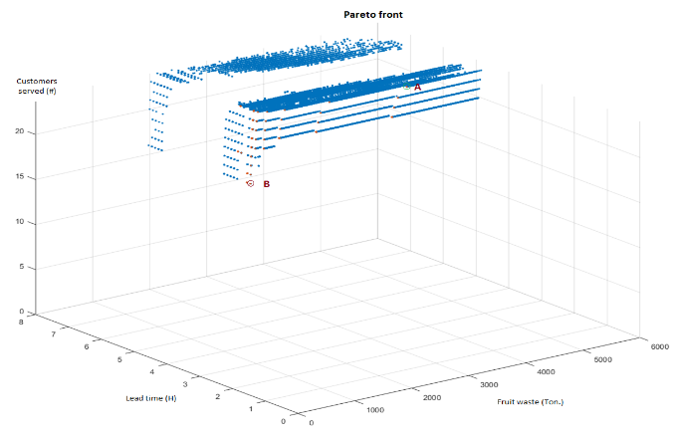
- Efficient Pareto Borders (974) for the deficit sub-model
Figure 3. Pareto borders for the two sub-models.
  - Sub-Models
To carry out the analysis that allows the best decision making for the stakeholders, the configurations for the extremes of the two sub-models were made; this means three configurations where each objective is optimal and another one with the medium statistics ones in search of the balance between the three performance measures. Then, the non-dominated point near it was searched for. Table 1 The CCs and WDs open for each configuration of the two sub-models are presented; the shaded columns correspond to the deficit sub-model, while the others to the surplus model.

Objective | Objective Min BJ1 | Objective Min BJ1 | Objective Min BJ2 | Objective Max BJ3 | Objective Min BJ4 | Objective Max BJ5 | Seeking Balance Another With the Median of  Obj1, 2 and 3 | Looking for the Balance Another With the Median of Obj1, 4 and 5
Objective | Minimize Losses |  | Minimize Transportation Costs | Maximize Farmers suppliers | Minimize Service Time | Maximize Customers Served | Seeking Balance Another With the Median of  Obj1, 2 and 3
Units | Thousands ($) | Thousands ($) | Ten thousand of millions ($) | Number of Municipalities | Minimize attention time (LT) | Number of customers served | Seeking Balance Another With the Median of  Obj1, 2 and 3
Optimum value | 2.16 | 1.98 | 36.2 | 24 | 4.4 | 12 | Seeking Balance Another With the Median of  Obj1, 2 and 3
Location | Open collection centers
Anapoima (25) | 25 | 25 | 25 | 25 | NC | NC | 25 | 25
Cachipay (26) | 26 | 26 | 26 | 26 | NC | 26 | 26 | 26
La Mesa (27) | 27 | 27 | 27 | 27 | 27 | NC | 27 | 27
Tocaima (28) | NC | NC | NC | NC | NC | 28 | NC | NC
San Bernardo (29) | NC | NC | 29 | NC | 29 | 29 | 29 | 29
Sibate (30) | 30 | 30 | 30 | 30 | 30 | 30 | 30 | 30
Location | Open Distribution Centers
Codabas (31) | NC | NC | 31 | 31 | NC | 31 | 31 | 31
Ciudad Bolívar (32) | 32 | 32 | 32 | 32 | NC | 32 | 32 | 32
Corabastos (33) | 33 | 33 | 33 | 33 | 33 | NC | 33 | 33
Paloquemao (34) | NC | NC | 34 | 34 | NC | 34 | 34 | 34
NC: Not Chosen
Table 1. Location of Collection Centers (Cundinamarca) and Distribution (Bogotá D.C)
Table 1, shows the different configurations of the logistics network. For objective 1, the same location is obtained for both CCs and WDs in the two sub-models, as well as in the medium-sized objectives. For the surplus sub-model, the same locations of the WDs with objectives 2 and 3 are obtained. When prioritizing the other objectives, different locations are obtained, it should be noted that no matter the objective, CCs 30 would always open (in the municipality of Sibate). As an illustration on map 1, the locations with the objective one and the medians are presented.
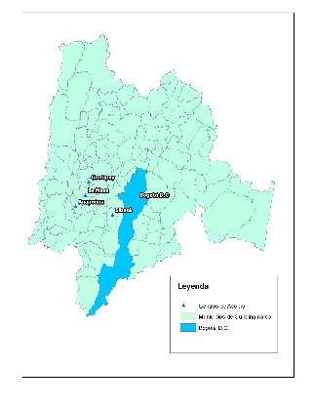 | 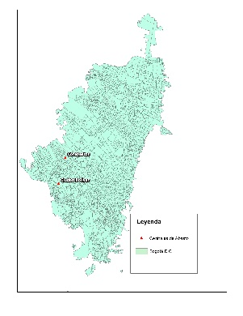
- OBJ1 CCs in Cundinamarca | - OBJ1D WDs in Bogota
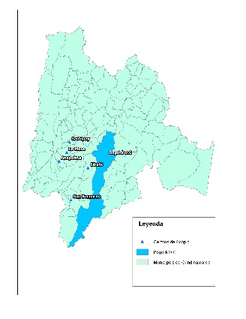 | 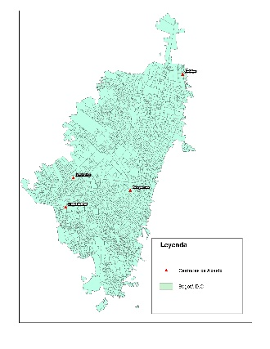
(c) OBJ medians CCs in Cundinamarca | (d) OBJ medians WDs in Bogota

Map 1. Collection Centers (CC) and Wholesaler Distribution Center (WD)
Figure 4 shows the flows derived from the configurations presented on map 1, in the case of warm-weather fruits. It can be seen that although it has the same locations for CCs and WDs, the flows between the echelons are different between the surplus and deficit sub-model.
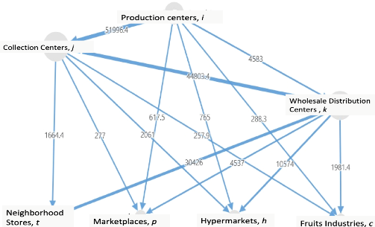 | 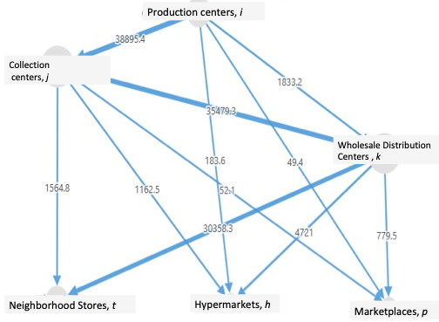
- Objective 1: Loss Minimization surplus | - Objective 1: Loss Minimization deficit
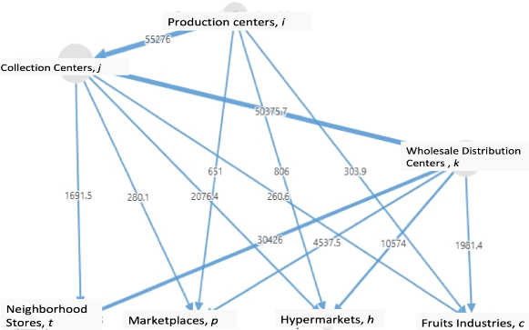 | 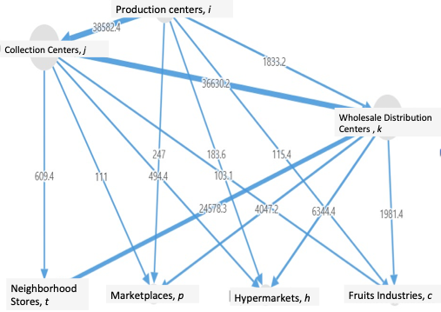
(c) With the medians of the three objectives surplus | (d) With the medians of the three objectives deficit

Figure 4. Flows based on objectives, warm climate fruits.
  - Discussion of results
The configuration establishes the location of CCs facilities in regions of fruit production and WDs in areas of consumption, by applying the two sub-models, one for moments of surplus and another for periods of deficit. The multi-objective, multi-product and multi-level optimization models designed, allowed showing different designs of the logistics network and different flows between the echelons. With an appropriate SCPFr LND and adequate logistic means, transportation and specialized warehouses, losses will be reduced and response capacity will be improved. The existence of intermediate nodes allows the consolidation of orders and food preservation, achieves economies of scale by moving volumes, a fundamental element in the performance of the SCPFr, and shows that actors can move to borders that are more efficient. Due to the tradeoff found among the performance measures, in order to decide what the appropriate configuration should be with respect to the five objectives evaluated, government institutions and unions should gather the different agents of the SCPFr and apply multi-goal models, given various interests of actors.
In times of surplus, the most affected are the producers, due to the low sales prices that do not cover their costs, the most benefited are the consumers as access is increased, in these periods of oversupply the availability will can be jeopardized discouraging the production. In times of scarcity an opposite effect is generated, producers earn with high prices and consumption is discouraged. The two multi-objective optimization models designed exceed what was found in the literature by including on one hand the effects of T0 and RH, recommendation made by (J. G. van der Vorst & Schouten, R E; Luning, P A; van Kooten, 2014).
When contemplating the different thermal floors and the means used for the transport of fruits in mountain areas, geographic region where the case study is applied, in countries in route of development; the models give a better representation of reality for SCPFr, manifest lack in the studies of (Akkerman et al., 2010; Goetschalckx et al., 2002; Soto-Silva et al., 2016; Soto Silva et al., 2017). The design of a multi-objective and multi-level model includes all the echelons of the SCPF from production to consumption, respond to the call of authors such as (Manzini & Accorsi, 2013; J. G. A. J. Van der Vorst et al., 2011; Yu & Nagurney, 2013) that demand the inclusion of supply, distribution and demand by containing all the echelons of the SCPFr.
There are several studies that show the need to allow the plurality of actors at the ends of the PFSC, in the field of producers (Bosona & Gebresenbet, 2011), in the field of retailers (Accorsi et al., 2018). This research contributes in these two ways, by developing the two sub-models for oversupply and fruit deficit. On one hand, availability is achieved with the diversity of producers; the offer in developing countries is guarantor of food security. On the other hand, the large number of retailers, shopkeepers in the neighborhood, counteracts the monopolies of large stores and favors access by guaranteeing competition.
- Conclusions and future work
Developing countries that are immersed in internal conflicts require government strategies and actions that allow alternatives to overcome the inequalities present among PFSC agents. In this sense, different interests in the actors that derive in tradeoffs arise. The measures of performance sought should lead to the sustainability of the chain to way that guarantees food security, which is why five objectives are proposed: efficiency, responsiveness, quality, permanence of farmers (supply) and from small shopkeepers (demand)
Seasonality in some fruits generates problems of oversupply and shortage in different periods of time this unbalances the logistics flows. For this reason, two models were designed, one of surplus and one of deficit. When running the two sub-models, the results derive different configurations with the five objectives and generate different flows between the echelons and different networks logistics design.
The multi-objective, multilevel and multiproduct model, exceeds what is found in the literature and approaches the reality of SCPFs by including logistic operation conditions of countries under development with mountain geography FS, where changes in T0 (temperature) and RH (relative humidity) affect the quality of fruits
It is necessary to evaluate the transition from one model to another, with the smallest impacts. In other words, given the optimal configuration for deficit, how will be reconfiguring the network for moments of surplus? In a planning horizon, given the network is A, how can pass it to B? with the improvement of the established performance measures, so that changes by periods are controlled. Therefore, the diversity of results, generate the need to propose the study with a dynamic approach to the design of logistics networks for PFSC that present seasonality. Being a multi-objective model, for decision making by decision makers, this study could be complemented by a multicriteria model.

- Appendix: Sets and parameters, model
  - Sets
I=Areas of agricultural production, index i | (7)
J=Possible location areas of the storage centers index j | (8)
K=Possible location areas of wholesale centers, index k | (9)
F=Types of perishable foods, index f | (10)
P=Market places, index p | (11)
H=Hypermarkets, index h | (12)
C=Centers of productive transformation, index p | (13)
DT=set of all possible destinations, index d, DT=(J∪K∪P∪T∪H∪C) | (14)
FDT{d}=Set of types of perishable food that can receive the destination d∈DT | (15)
DTF{f}=Destination set d∈DT that can receive perishable food f | (16)
OT=set of all possible origins, index o, OT=(I∪J∪K) | (17)
FOT{o}=Set of perishable food types that can be sent by the origin or ∈ OT | (18)
DI=set of intermediate and final destinations, index d3, DI=(K∪P∪T∪H∪C) | (19)
$${DNT}_{d2}=\sum_{f∈FDF\left\{d2\right\}}{{DN}_{fd2}}=Totaldemandoncustomerd2∈DF$$ | (20)
FJ{j}=Types of perishable goods that can be received in the storage area j | (21)
FI{i}=Types of perishable goods found in the area of agricultural production i | (22)
  - Parameters
CF_{j} =Fixed cost of the central storage located in j | (23)
CT_{od} =Transport cost between the origin oro ∈ OT to destination d∈DTOT{o} | (24)
CP_{f} = Cost of loss of perishable food type f | (25)
DN_{fd2} =Final destination demand d2∈ DF, of the type of perishable good f∈FDF{d2} | (26)
DIN_{od} =Distance between the origin o ∈ OT to destiny d∈DTOT{o} | (27)
TN_{od} =Loss percentage due to temperature change between the origin o ∈ OT to destiny d∈DTOT{o} | (28)
Hn_{od} =Loos percentage due to HR between the origin o ∈ OT to destiny d∈DTOT{o} | (29)
LTD2E_{d2} =definition of attention time estimated | (30)
  - Decision Variables

Opening variables
$$X_{j}=\left\{\begin{matrix}1Ifacollectioncentreisopened∈theareaj \\ 0Onthecontrary\end{matrix}\right\}$$ | (31)
$$X_{j}=\left\{\begin{matrix}1Ifacollectioncentreisopened∈theareaj \\ 0Onthecontrary\end{matrix}\right\}$$ | (32)
$$Y_{k}=\left\{\begin{matrix}1Ifadistributioncentre\left(wholesale\right)isopened∈theareak \\ 0Onthecontrary\end{matrix}\right\}$$ | (33)
$${BPI}_{i}=\left\{\begin{matrix}1iftheproduceri∈isconsidered \\ 0Onthecontrary\end{matrix}\right\}$$ | (34)

Flow variables
WN_{fod} =Amount of the type of perishable food f to send from O to D. ∀ O∈OT, ∀ D∈DT,∀ f∈F | (35)

Excess of offer:
SFI_{fo}=Amount of perishable food type f oversupply in echelon o,∀ o∈ I,J,K | (36)
SFID_{fd2}=Amount of the type of perishable food f coming from the link e overbid in the final destination d2 ,∀ e∈ I,J,K; ∀d2∈ DF;∀ f∈FDF{d2} | (37)

Declaration of Conflicting Interests
The author(s) declared no potential conflicts of interest with respect to the research, authorship, and/or publication of this article.
Note: if there is some conflicting interest, please detail it.

Funding
The author(s) received no financial support for the research, authorship, and/or publication of this article.
Note: if the author(s) received financial support, please detail it.

References
Accorsi, R., Baruffaldi, G., Manzini, R., & Tufano, A. (2018). On the design of cooperative vendors’ networks in retail food supply chains: a logistics-driven approach. International Journal of Logistics Research and Applications, 21(1), 35–52. https://doi.org/10.1080/13675567.2017.1354978
Akkerman, R., Farahani, P., & Grunow, M. (2010). Quality, safety and sustainability in food distribution: A review of quantitative operations management approaches and challenges. In OR Spectrum (Vol. 32, Issue 4). https://doi.org/10.1007/s00291-010-0223-2
Aramyan, L., Ondersteijn, C. J. M., KOOTEN, O. VAN, & Oude Lansink, A. (2006). Performance indicators in agri-food production chains. Quantifying the Agri-Food Supply Chain, 49–66. https://doi.org/10.1007/1-4020-4693-6_5
Argenti , Olivio Marocchino, C. (2007). Abastecimiento y distribución de alimentos en las ciudades. Gestion, Comercializacion y Finanzas Agricolas Documento Ocasional, 27–30.
Bigliardi, B., & Bottani, E. (2010). Performance measurement in the food supply chain: a balanced scorecard approach. Facilities, 28(5–6), 249–260. https://doi.org/10.1108/02632771011031493
Bosona, T. G., & Gebresenbet, G. (2011). Cluster building and logistics network integration of local food supply chain. Biosystems Engineering, 108(4), 293–302. https://doi.org/10.1016/j.biosystemseng.2011.01.001
Boudahri, F., Aggoune-Mtalaa, W., Bennekrouf, M., & Sari, Z. (2013). Application of a Clustering Based Location-Routing Model to a Real Agri-food Supply Chain Redesign. In N. Thanh Nguyen, B. Trawinski, R. Katarzyniak, & G.-S. Jo (Eds.), Advanced Methods for Computational Collective Intelligence. Studies in Computational Intelligence (457th ed., pp. 323–331). Springer-Verlag.
CISAN-ICBF. (2013). Instituto Colombiano de Bienestar Familiar ICBF, Conpes 113 2008. http://www.icbf.gov.co/portal/page/portal/PortalICBF/Bienestar/Nutricion/PNSAN
Clark, J. K., & Inwood, S. M. (2016). Scaling-up regional fruit and vegetable distribution: potential for adaptive change in the food system. Agriculture and Human Values, 33(3), 503–519. https://doi.org/10.1007/s10460-015-9618-7
de Keizer, M., Akkerman, R., Grunow, M., Bloemhof, J. M., Haijema, R., & van der Vorst, J. G. A. J. (2017). Logistics network design for perishable products with heterogeneous quality decay. European Journal of Operational Research, 262(2), 535–549. https://doi.org/10.1016/j.ejor.2017.03.049
Farahani, R. Z., Rezapour, S., Drezner, T., & Fallah, S. (2014). Competitive supply chain network design: An overview of classifications, models, solution techniques and applications. Omega (United Kingdom), 45, 92–118. https://doi.org/10.1016/j.omega.2013.08.006
Gerber, A. (2014). Food Security as an Outcome of Food Systems A Feedback Perspective. System Dynamics Conference, 1, 1–18.
Gligor, D., Tan, A., & Nguyen, T. N. T. (2018). The obstacles to cold chain implementation in developing countries: insights from Vietnam. International Journal of Logistics Management, 29(3), 942–958. https://doi.org/10.1108/IJLM-02-2017-0026
Goetschalckx, M., Vidal, C. J., & Dogan, K. (2002). Modeling and design of global logistics systems: A review of integrated strategic and tactical models and design algorithms. European Journal of Operational Research, 143(1), 1–18. https://doi.org/10.1016/S0377-2217(02)00142-X
Gong, W., Li, D., Liu, X., Yue, J., & Fu, Z. (2007). Improved two-grade delayed particle swarm optimisation (TGDPSO) for inventory facility location for perishable food distribution centres in Beijing. New Zealand Journal of Agricultural Research, 50(5), 771–779. https://doi.org/10.1080/00288230709510350
Govindan, K. ., Jafarian, A. ., Khodaverdi, R. ., & Devika, K. . (2014). Two-echelon multiple-vehicle location-routing problem with time windows for optimization of sustainable supply chain network of perishable food. International Journal of Production Economics, 152, 9–28. https://doi.org/10.1016/j.ijpe.2013.12.028
Gustavsson J, Cederberg C, Sonesson U, F. (2011). Pérdidas y desPerdicio de alimentos en el mundo. http://www.fao.org/docrep/016/i2697s/i2697s.pdf
Hammond, R. A., & Dubé, L. (2012). A systems science perspective and transdisciplinary models for food and nutrition security. Proceedings of the National Academy of Sciences of the United States of America, 109(31), 12356–12363. https://doi.org/10.1073/pnas.0913003109
Hsiao, Y. H., Chen, M. C., Lu, K. Y., & Chin, C. L. (2018). Last-mile distribution planning for fruit-and-vegetable cold chains. International Journal of Logistics Management, 29(3), 862–886. https://doi.org/10.1108/IJLM-01-2017-0002
IICA-PRODAR, F. (2009). Gestión de agronegocios en empresas asociativas rurales: Curso de capacitación. Módulo 1: Sistema agroproductivo, cadenas y competitividad.
Johnson, P.-N. T., Nketia, S., & Quaye, W. (2015). Appraisal of Logistics Management Issues in the Agro-Food Industry Sector in Ghana. Journal of Agricultural Science, 7(3), 164–178. https://doi.org/10.5539/jas.v7n3p164
Lemma, Y., Kitaw, D., & Gatew, G. (2014). Loss in Perishable Food Supply Chain: An Optimization Approach Literature Review. International Journal of Scientific & Engineering Research, 5(5), 302–311.
Lowe, T. J., & Preckel, P. V. (2004). Decision technologies for agribusiness problems: A brief review of selected literature and a call for research. Manufacturing and Service Operations Management, 6(3), 201–208. https://doi.org/10.1287/msom.1040.0051
Manzini, R., & Accorsi, R. (2013). The new conceptual framework for food supply chain assessment. Journal of Food Engineering, 115(2), 251–263. https://doi.org/10.1016/j.jfoodeng.2012.10.026
Miranda-Ackerman, M. A., Azzaro-Pantel, C., & Aguilar-Lasserre, A. A. (2017). Sustainability assessment of a transportation system under uncertainty: an integrated multicriteria approach. IFAC-PapersOnLine, 50(1), 7481–7486. https://doi.org/10.1016/j.ifacol.2017.08.1064
Musavi, M. M., & Bozorgi-Amiri, A. (2017). A multi-objective sustainable hub location-scheduling problem for perishable food supply chain. Computers and Industrial Engineering, 113, 766–778. https://doi.org/10.1016/j.cie.2017.07.039
Novaes, A. G. N., Lima, O. F., De Carvalho, C. C., & Bez, E. T. (2015). Thermal performance of refrigerated vehicles in the distribution of perishable food. Pesquisa Operacional, 35(2), 251–284. https://doi.org/10.1590/0101-7438.2015.035.02.0251
Orjuela-Castro, J. A., & Adarme-Jaimes, W. (2018). Evaluating the Supply Chain Design of Fresh Food on Food Security and Logistics. In Communications in Computer and Information Science (Vol. 915). Springer International Publishing. https://doi.org/10.1007/978-3-030-00350-0
Orjuela-Castro, J. A., Batero-Manso, D., & Orejuela, J. P. (2018). Logistics IRP Model for the Supply Chain of Perishable Food. In J. C. Figueroa-García, J. G. Villegas, J. R. Orozco-Arroyave, & P. A. Maya Duque (Eds.), Applied Computer Sciences in Engineering (pp. 40–52). Springer International Publishing.
Orjuela-Castro, J. A., Sanabria-Coronado, L. A., & Peralta-Lozano, A. M. (2017). Coupling facility location models in the supply chain of perishable fruits. Research in Transportation Business and Management, 24(August), 73–80. https://doi.org/10.1016/j.rtbm.2017.08.002
Orjuela Castro, J. A., Aranda Pinilla, J. A., & Moreno Mantilla, C. E. (2019). Identifying trade-offs between sustainability dimensions in the supply chain of biodiesel in Colombia. Computers and Electronics in Agriculture, 161(March 2018), 162–169. https://doi.org/10.1016/j.compag.2018.03.009
Orjuela Castro, J. A., Diaz G, G. L., & Bernal C, M. P. (2017). Model for Logistics Capacity in the Perishable Food Supply Chain. Communications in Computer and Information Science, 742, III–IV. https://doi.org/10.1007/978-3-319-66963-2
Orjuela Castro, J. A., Díaz Ríos, O. J., & González Pérez, Á. Y. (2017). Caracterización de la logística en la cadena de suministro de cosméticos y productos de aseo. Revista Científica, 28(28), 84–98. https://doi.org/10.14483/udistrital.jour.rc.2016.28.a7
Orjuela Castro, J. A., & Jaimes, W. A. (2017). Dynamic impact of the structure of the supply chain of perishable foods on logistics performance and food security. Journal of Industrial Engineering and Management, 10(4 Special Issue), 687–710. https://doi.org/10.3926/jiem.2147
Orjuela Castro, J. A., Orejuela, J. P., & Adarme Jaimes, W. (2019). Last mile logistics in mega-cities for perishable fruits. Journal of Industrial Engineering and Management, 12(2), 318. https://doi.org/10.3926/jiem.2770
Renting, H., Marsden, T. K., & Banks, J. (2003). Understanding alternative food networks: Exploring the role of short food supply chains in rural development. Environment and Planning A, 35(3), 393–411. https://doi.org/10.1068/a3510
Shannon N. Zenk, Amy J. Schulz, Srimathi Kannan, Laurie L. Lachance, Graciela Mentz, & William Ridella. (2012). Neighborhood Retail Food Environment and Fruit and Vegetable Intake in a Multiethnic Urban Population. Am J Health Promot, 23(4), 255–264. https://doi.org/10.4278/ajhp.071204127.Neighborhood
Shashi, Cerchione, R., Singh, R., Centobelli, P., & Shabani, A. (2018). Food cold chain management: From a structured literature review to a conceptual framework and research agenda. International Journal of Logistics Management, 29(3), 792–821. https://doi.org/10.1108/IJLM-01-2017-0007
Soto-Silva, W. E., Nadal-Roig, E., González-Araya, M. C., & Pla-Aragones, L. M. (2016). Operational research models applied to the fresh fruit supply chain. European Journal of Operational Research, 251(2), 345–355. https://doi.org/10.1016/j.ejor.2015.08.046
Soto Silva, W. E., González Araya, M. C., Oliva Fernández, M. A., & Plà Aragonés, L. M. (2017). Optimizing fresh food logistics for processing: Application for a large Chilean apple supply chain. Computers and Electronics in Agriculture, 136, 42–57. https://doi.org/10.1016/j.compag.2017.02.020
Sun, X., Wu, C. C., & Chen, L. R. (2018). Cold Chain Logistics Distribution Optimization for Fresh Processing Factory Based on Linear Programming Model. Proceedings of 2018 IEEE 3rd Advanced Information Technology, Electronic and Automation Control Conference, IAEAC 2018, Iaeac, 593–597. https://doi.org/10.1109/IAEAC.2018.8577759
Tsao, Y. C. (2013). Designing a fresh food supply chain network: An application of nonlinear programming. Journal of Applied Mathematics, 2013. https://doi.org/10.1155/2013/506531
Utomo, D. S., Onggo, B. S., & Eldridge, S. (2018). Applications of agent-based modelling and simulation in the agri-food supply chains. European Journal of Operational Research, 269(3), 794–805. https://doi.org/10.1016/j.ejor.2017.10.041
Van der Vorst, J G; Da Silva, C. A, C A; Trieneken, J. H. (n.d.). 2007 Angro-industrial supply chain management.
Van der Vorst, J. G. A. J., Van Kooten, O., & Luning, P. a. (2011). Towards a diagnostic instrument to identify improvement opportunities for quality controlled logistics in agrifood supply chain networks. International Journal on Food System Dynamics, 2(1), 94–105. http://centmapress.ilb.uni-bonn.de/ojs/index.php/fsd/article/view/119
van der Vorst, J. G., & Schouten, R E; Luning, P A; van Kooten, O. (2014). Designing new supply chain networks: tomato and mango case studies. Horticulture: Plants for People and Places, Volume 1: Production Horticulture, 1, 1–599. https://doi.org/10.1007/978-94-017-8578-5
WFPC LLC. (2014). The WORLD FOOD PRESERVATION CENTER LLC. http://worldfoodpreservationcenter.com/research.html
Yakavenka, V., Mallidis, I., Vlachos, D., Iakovou, E., & Eleni, Z. (2019). Development of a multi-objective model for the design of sustainable supply chains: the case of perishable food products. Annals of Operations Research, 0123456789. https://doi.org/10.1007/s10479-019-03434-5
Yu, M., & Nagurney, A. (2013). Competitive food supply chain networks with application to fresh produce. European Journal of Operational Research, 224(2), 273–282. https://doi.org/10.1016/j.ejor.2012.07.033

